ICS-344 - Information Security
Section 02
Ali Kamal Aloryd 202322750
Redha Abdulaziz Alturaik 20232301
http://dvsa-website-test-546079881937-us-east-1.s3-website.us-east-1.amazonaws.com/
us-east-1 (N. Virginia)
Date: 19 April 2026
Vulnerable Dependencies
Lesson - 9

Goal and Vulnerability Summary
The goal of this lesson is to demonstrate a Vulnerable Dependencies issue in the DVSA serverless application. The backend relies on an outdated and insecure third-party library (node-serialize) that introduces a critical security flaw. This dependency allows execution of attacker-controlled code during deserialization, leading to Remote Code Execution (RCE). The objective is to identify the vulnerable dependency and explain how it expands the attack surface of the application.

Why This Works / Root Cause
The vulnerability exists because the application uses an outdated and insecure third-party library (node-serialize) that performs unsafe deserialization. Unlike secure JSON parsing methods, this library allows serialized functions to be executed automatically. The root cause is not only improper input handling, but also poor dependency management. The application trusts an external library without verifying its security, allowing malicious input to be executed during the deserialization process.

Environment and Setup
The DVSA application is deployed in AWS (us-east-1) using API Gateway, AWS Lambda, and DynamoDB. The vulnerable component is the DVSA-ORDER-MANAGER Lambda function. The dependency node-serialize is included in the backend code and is used to deserialize incoming request data.
Tools used:
- AWS Console (Lambda code inspection)
- CloudWatch Logs
- curl (for testing exploit)

Intended Logic & Workflow
In a secure system, third-party dependencies should only process data safely and must not execute any user-controlled input. The Lambda function should parse incoming requests using secure methods such as JSON.parse(), ensuring that input is treated strictly as data.The application should rely on trusted, maintained libraries that do not introduce execution risks. Additionally, dependencies should be regularly reviewed and updated to prevent known vulnerabilities.

Reproduction Steps
Step 1 - Identify Vulnerable Dependency
- Go to AWS Console
- Open Lambda than DVSA-ORDER-MANAGER
- Open-source code
- Locate: const serialize = require('node-serialize');
Step 2 - Observe Unsafe Deserialization
- Locate: var req = serialize.unserialize(event.body);
Step 3 - Confirm Exploit via Dependency
Run the same payload (from Lesson 1):
curl -X POST "YOUR_API/order" \
-H "Content-Type: application/json" \
-d '{"action":"_$$ND_FUNC$$_function(){console.error(\"PWNED\")}()","cart-id":""}'
Step 4 - Verify Execution
- Go to CloudWatch: /aws/lambda/DVSA-ORDER-MANAGER
- Look for: PWNED

Evidence and Proof
The presence of the node-serialize library in the Lambda function confirms that the application depends on an insecure third-party package. The exploit demonstrates that this dependency allows execution of attacker-controlled input. Although the API returns an "Internal server error", the exploit is successful because the malicious code executes before the application crashes. This behavior is confirmed through CloudWatch logs.
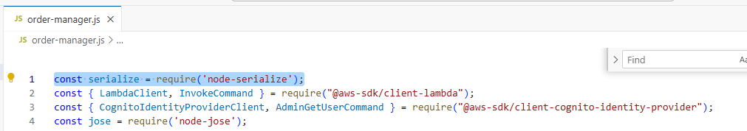
Figure 1.Lambda code showing node-serialize
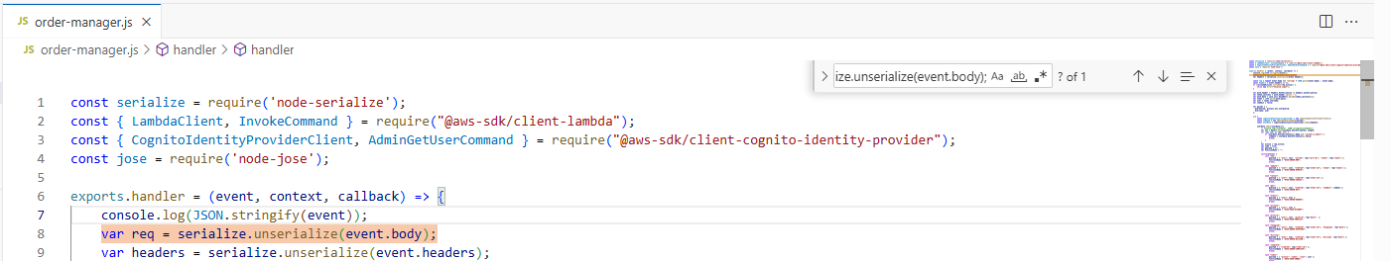
Figure 2. Code showing unsterilized
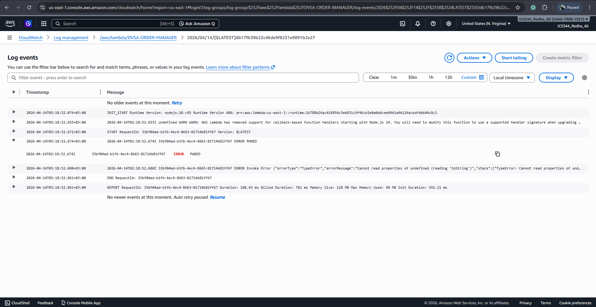
Figure 3. CloudWatch showing execution

Fix Strategy / Probable Mitigation
The presence of the node-serialize library in the Lambda function confirms that the application depends on an insecure third-party package. The exploit demonstrates that this dependency allows execution of attacker-controlled input.
Although the API returns an "Internal server error", the exploit is successful because the malicious code executes before the application crashes. This behavior is confirmed through CloudWatch logs.
- Regularly updating libraries
- Reviewing third-party code
- Using dependency scanning tools

Code / Config Changes
Before (vulnerable):
const serialize = require('node-serialize');
var req = serialize.unserialize(event.body);
After (secure):
const req = typeof event.body === "string" ? JSON.parse(event.body) : event.body;

Verification After Fix
After removing the vulnerable dependency, the same malicious payload was tested again. The system no longer executed the injected code, and no "PWNED" message appeared in CloudWatch logs. This confirms that removing the insecure dependency successfully eliminates the vulnerability.

Structured Operation and Security Analysis

Table 1: Structured analysis summary — Table A
Vulnerability | Intended Rule(s) | Artifacts Used to Infer Rule | Normal Behavior Evi dence | Exploit Behavior Evi dence
Vulnerable Dependencies | Dependencies must not execute user input | Lambda code, CloudWatch logs | Safe parsing expected | Execution via dependency

Table 2: Structured analysis summary — Table B:
Vulnerability | Why This Is a Deviation | Deviation Class | Fix Applied  (where) | Post-Fix Verification
Vulnerable Dependencies | Insecure library executes user input | Misconfiguration | Removed node-serialize in Lambda | No execution after fix

Takeaway / Lessons Learned
This lesson highlights that vulnerable third-party dependencies can introduce critical security risks even if the application logic appears correct. In serverless environments, such vulnerabilities can lead to full compromise of backend functions. Developers must carefully select, monitor, and update dependencies to ensure they do not introduce security flaws into the system.

